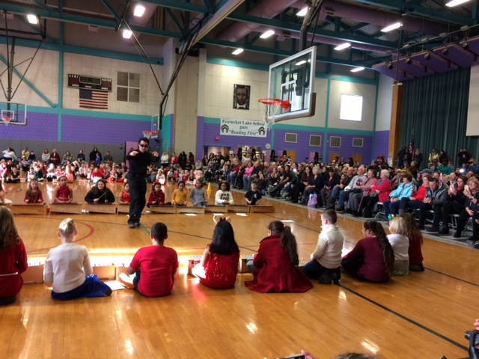 |  | Dear Families,  Reading each night supports children’s success in school by increasing reading stamina, enlarging vocabulary and supporting a love of reading. As your child’s first teachers, families can support literacy in a multitude of ways. Read at bedtime, on the bus, at the laundromat, anywhere and everywhere! When you run out of books, go to the library. There you’ll not only find a superb collection but it’s free! Make reading a part of your family routine; share poems, articles, newspapers and books with each other often.  In the month of February, we will celebrate random acts of kindness. We will host a school assembly to build school spirit, teamwork and respect. The PTO is hosting a school dance on Friday, February 14, 2020 at 6:30pm. We hope you can attend.

Pentucket lake elementary school winter performance

School Happenings

ELA Happenings
Teachers have completed assessing your child’s reading level in December and January. Our Kindergarten and Grade 1 students have been working hard with letters and sounds using the Letterland Program. Ask your child about the Letterland. Students are continuing to enjoy classroom read aloud and independent reading time during reader’s workshop. Reading together at home is an important way to reinforce the skills that your child is learning in school. Find a great book to read together, make it fun, and enjoy that special time.
Math Happenings
Students have been busy with our primary math program, enVisionmath 2.0. This is an online digital math program. The lessons are taught using interactive visual learning animations. Every lesson begins with rich problem solving and discussion. In addition to traditional paper pencil practice, students are able to complete online assignments using chromebooks. Students are also working hard using the ST Math program twice a week. ST Math is a supplemental, self-paced program that builds a deep conceptual understanding of math through rigorous learning and creative problem solving. It requires very little reading, so it is accessible to all students, regardless of reading level.
Art Happenings with Mr. Murray
4th Grade - UMass Lowell RiverHawks Basketball Drawing Contest
Students are helping to decorate UMass Lowell's Tsongas Arena for an upcoming rivalry basketball game. Students will learn about the local university and have their artwork will be displayed for the game on February 1st.
3rd Grade - Casella Recycling Calendar Contest This is an opportunity for students to create a picture showing the importance of recycling and taking care of the environment. Pentucket Lake has had a winning drawing for the last two years, which has been published in the Casella Calendar!
2nd Grade - Mandallas Students will learn about radial symmetry and will create beautiful original designs to be on display towards the end of the month.
1st Grade - Cut and Paste Snow Men Students are continuing to practice with using scissors and glue to create snow men with multiple layers.
K- "Tear and Share" Related to Amy Rosenthal and Tom Lichtenheld's New York Times best seller Friendshape, Students will receive a strip of colored paper in order to tear and share with fellow students, in order to with the goal of collecting all 6 colors in the rainbow.

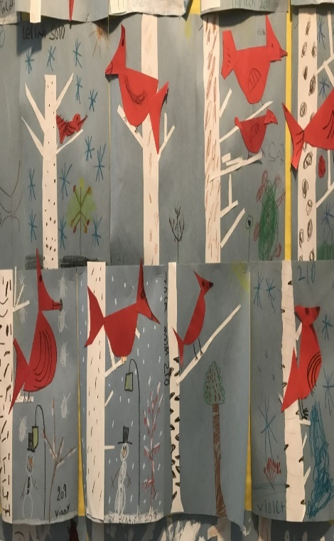
Cardinals in the Birch

Music Happenings with Mr. Ferland
4th Grade: This semester, 4th graders are working on their concert material for their end of the year performance. They are working on songs that incorporate singing, moving, and instruments.
3rd Grade: This semester, 3rd graders are working on their concert material for their end of the year performance. They are working on songs that incorporate singing, moving, and instruments.
2nd Grade: This semester, 2nd graders are working on proper mallet technique at the barred instruments. They are practicing songs that require them to keep the steady beat, play the rhythm, and sing the words.
1st Grade: This semester, 1st graders are working on longer folk dances that require focus, listening, and internalizing the steady beat.
K: This semester, kindergartners are working on folk dances that require partner changes, being respectful to each other, and keeping the steady beat.

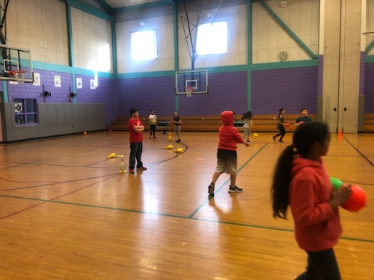
In the Gym with Mr. Carven

I will be teaching lessons using hands (volleying) jump ropes, sticks, rackets, and paddles. Such skills as serve/ forehand / backhand stroke, stick handling and shooting will be learned along with games to incorporate these skills.
In February, the American Heart Association's Jump Rope for Heart fundraiser will take place leading up to and during this event, children will be learning different types of individual and group jump roping skills. More information on Jump Rope for Heart will be sent home in February.

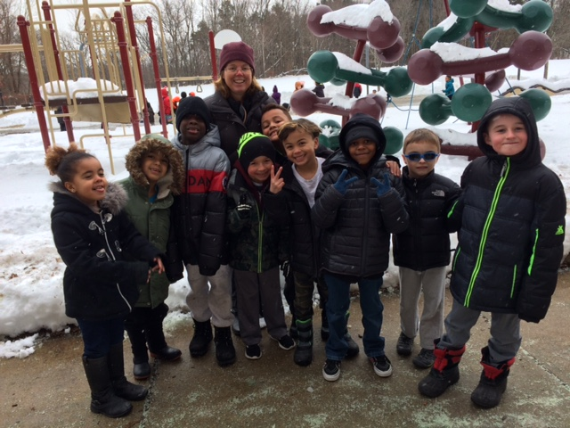

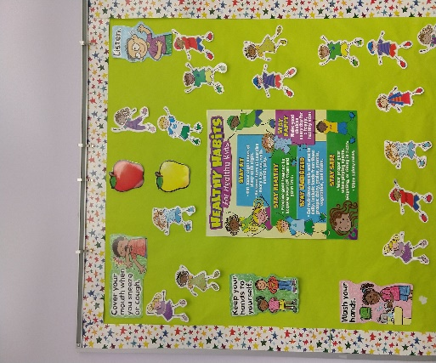

Nursing Notes
by Nurse Katrina

Over the past week, I have seen an increase in influenza (the flu) cases. The flu is an infection that causes symptoms such as fever, cough, stuffy or runny nose, sore throats, fatigue, body aches and headaches. If your child has these symptoms please contact their doctor as they can be treated if they are seen within the first couple of days of illness.

I would like to remind you that if your child is sick, please keep them home until they are fever, vomiting and diarrhea free for 24 hours with no medication.

We are taking all necessary steps to make sure the school is “well-scrubbed” and has been cleaned in a more aggressive manner these past few weeks. We will continue to keep families informed as information becomes available.

Please visit our Pentucket Elementary School website or https://www.cdc.gov/flu/.

It is never too late to get your flu shot!

PENTUCKET LAKE SCHOOL
PHONE # 978-374-2421
Mrs. Gray, Principal
Mr. Brennan, Assistant Principal

